Evolution Assignment 2: Genetic Drift

This is your second assignment for Topic 9, worth 2.5 % of your course. Ensure that you complete both: Part 1 (worth 1.5 %) and Part 2 (worth 1%)

Part 1: Questions regarding genetic drift
Use the graphs below to answer questions 1-8, (short answer, 1-2 sentences or bullet points)

The graphs below show simulations of two scenarios regarding one gene (alleles A/a):

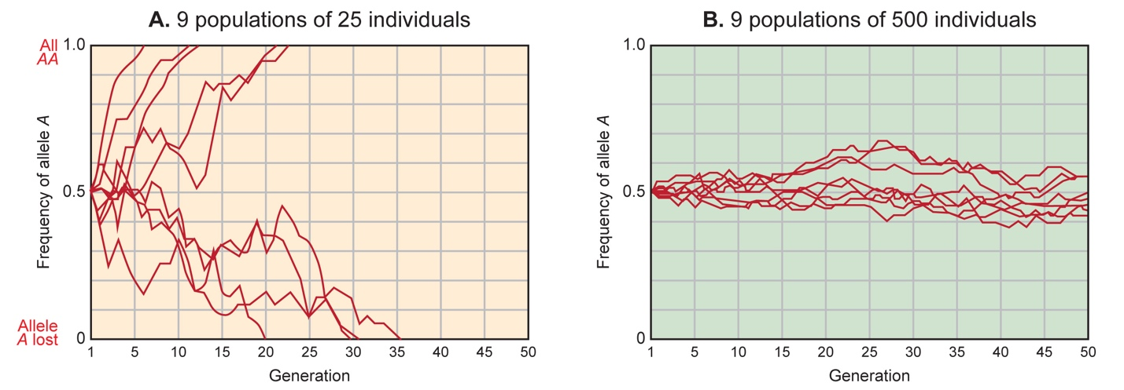
Source of graphs: https://evolution.berkeley.edu/evolibrary/home.php

1) Explain what is shown on the x- and y-axes. 1 pt
2) Choose two lines on graph A, one that goes to the top of the graph and one that goes to the bottom. For each line, explain what the line represents and how it changes over time. Also, explain what it means when a line goes to the top of the graph versus what it means when a line goes to the bottom of the graph. 3 pts
3) Explain the difference between the simulations that generated graphs A and B. 1 pt
4) Why do y-values fluctuate in each graph? 1 pt
5) In graph A, how many of the trials resulted in a frequency of A = 1.0 and how many resulted in a frequency of a = 1.0? Why might this occur? 2 pts
6) The populations represented by graph A and graph B demonstrate very different behavior. What concept regarding genetic drift does this illustrate? 2 pts
7) If one allele were under selection in graph B (contributed negatively to fitness), how would this graph differ? 2 pts
8) How would each of these graphs differ if starting allele frequencies in the simulations were not 50/50—for example, if the populations began with 30% A allele and 70% a allele? Would drift occur? 3 pts Test your hypothesis in Part 2.

Part 1_______/ 15 = ________/1.5 %

Part 2: Simulation Exercise
Generate one simulation for allele A= 30 % in a small (25 individuals) and large (500 individuals) population. Compare and contrast your results, summarize (use “proportion of R allele” and allele proportion graph), provide a figure (e.g. screenshot of the data page) for each simulation. Did you observe genetic drift? If so, in which population and why? Briefly comment on the implications of your results regarding a threatened species like the Southern Mountain Caribou or the Polar Bear. Write a concise paragraph (about 100 words, provide a word count)

Use the following website (in addition link provided in this folder)
http://virtualbiologylab.org/ModelsHTML5/PopGenFishbowl/PopGenFishbowl.html
Read the background information, go through the tutorial and run two simulations:

Simulation A: A population with 25 individuals, carrying capacity of 25, ‘R’ allele = 0.3 (that corresponds to 30 % A), see screenshot below, run for a minimum of 50 generations, take a screenshot of your data (your Fig. 1)
Suggested Experimental Design A, but feel free change other parameter not given above (you would need to discuss this in your comments)
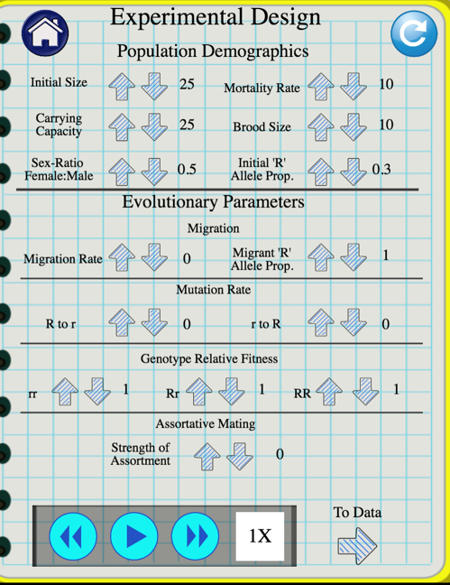

Simulation B: A population with 500 individuals, carrying capacity of 500, ‘R’ allele = 0.3 (that corresponds to 30 % A), see figure below, run for a minimum of 50 generations, take a screenshot of your data (your Fig. 2)
Suggested Experimental Design B, but feel free change other parameter (you would need to explain this in your comments)

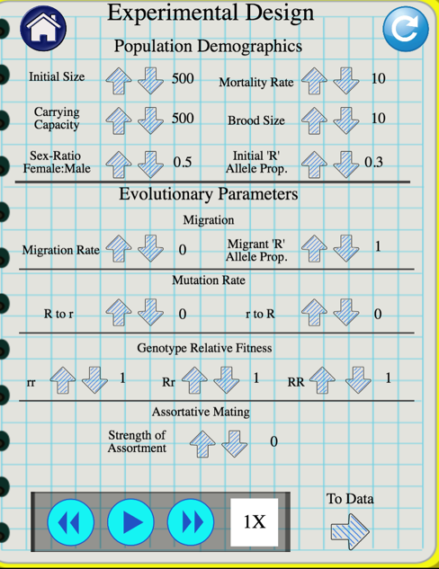

Marking Part 2:
3 points for screenshots of your results
4 points for written summary of results, including a comparison of your simulations, relate to your hypothesis from part 1
2 points for reasonable explanation of implications for a threatened species
1 point for grammar and structure (incl. word count)
Part 2: /10 = /1%

Example of output page /results screenshot:
Population size = 25, frequency R (or A) = 0.67 after 75 generations,
provide a concise and insightful explanation comparing the two populations (apply concepts from Topic 9) and relate to your hypothesis from part 1 for full marks.
